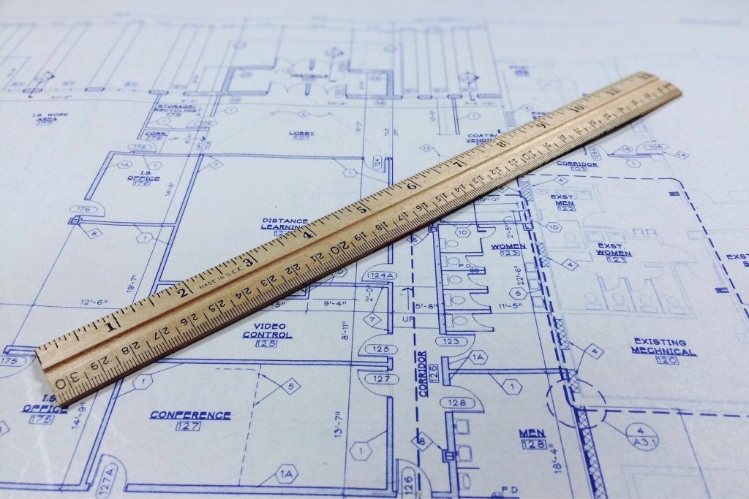

BLUEPRINT

for

BUILDING

a

BETTER PROPOSAL

Before You Start Building
Small and medium size construction companies struggle with preparing detailed and accurate proposals. This problem isn’t restricted only to small companies. It begins there, but as companies grow it only gets worse until they either get big enough to absorb the cost of guessing or give up trying and go out of business.
When I started doing construction more than forty years ago, I had no clue how to prepare proposals and like every other small construction company…I guessed. I used a common method called trial and error. Doing proposals this way is a real crap shoot and leaves room for mistakes.
Preparing accurate proposals that communicate clearly doesn’t have to be a roll of the dice.

I’ve tried several different computer estimating programs, but their numbers were based on national averages which was inaccurate locally. These systems were hard or impossible to modify or customize to meet my needs.
It was at that point I began working on a proposal system that worked the way I wanted it to. It’s gone through a lot of modifying and updating to become what it is now. Over the years I’ve been asked by other contractors how I do my proposals and where I got the program I use.
After being hired by some of those contractors to do proposals for them it became apparent that there was a real need for a better proposal system.
The “Blueprint for Building a Better Proposal” system will give you the documents and instructions needed for preparing proposals that communicate clearly and accurately with the customer, while allowing you to be profitable.
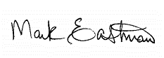
Let’s get started building,

Reasons Proposals Should Be Done
- Avoid miscommunication
- Satisfied customers
- Consistently profitable business
- Clear direction for production crews
- Budget numbers for production
- It’s the professional’s responsibility, not the customer’s

Reasons Proposals Aren’t Done
- Takes too much time
- Don’t like paperwork
- Don’t know how
- “We’ve always done it this way and it works just fine.”

Proposal Documents

Bid sheet – A Word document with the various construction categories and individual tasks listed with space for filling in the scope of the work to be done, dimensions, materials, locations, etc., for each category as needed for clear communication.
Worksheet – An Excel spreadsheet with all the construction categories and individual tasks listed with overhead and profit markup formulas.
Proposal – A word document with space to fill in pertinent information, i.e. customer’s information, what will or will not be supplied by the contractor, the scope of work, the proposed price for each specific element, a total project price, payment arrangements and project duration.
Data Base – An Excel spreadsheet with prices for material and labor for a wide variety of specific construction tasks. This information will be used to fill out a blank worksheet template by copying and pasting.

Blueprint for Building a Better Proposal
Overview
STEP 1 – Gathering Information
Gathering the right information correctly and effectively is critical to preparing an accurate and thorough proposal. Once you’ve been contacted by a potential customer start by scheduling a meeting to discuss their project and find out what they hope to accomplish. At this initial meeting gather –
Measurements and dimensions, existing and new
Building materials, existing and new
Pictures of pertinent areas and existing construction
Customer’s design ideas and finishes
The information gathered at this meeting can be recorded in whatever way works best for you. The important thing in this step is to gather any and all information needed to prepare an accurate proposal. It can be handwritten on a printed out Bid Sheet template, or it can be entered directly to a Bid Sheet using a tablet, smart phone or laptop. Using the Bid Sheet minimizes overlooking things because the different areas of a construction project are already listed.

STEP 2 – Preparing the Scope of Work
After the preliminary information has been gathered it’s time to clarify the scope of the project by writing out the description of each specific task in terminology that both the customer and the contractor understand. It needs to include enough specifics to be thorough without being too technical. It doesn’t help communication if the terminology is confusing to the customer. This written description on the Bid Sheet will be transferred to the Proposal and serve as a written scope of work to be performed and materials to be provided.

STEP 3 – Pricing the Project
Next is putting prices to the project. This process involves two different Excel spreadsheets, the Worksheet and Data Base. Based on the descriptions written on the Bid Sheet, content from the Data Base will be copied and pasted into the correlating cells on the Worksheet. After the pertinent information from the Data Base has been placed on the Worksheet it’s time to fill in the quantities.

STEP 4 - Quantities
On the Worksheet you will fill in the quantity needed to do the work on that line item. This may be lineal feet, square feet, square yards, cubic feet, cubic yards, numbers of pieces, etc. Once this is completed you will now have prices for each of the different tasks listed on the Proposal.

STEP 5 – Preparing the Proposal
Now you have everything you need to complete the Proposal. You will take the descriptions from the Bid Sheet and the prices from the Worksheet and put them both on the Proposal. After filling out the customer’s information at the top of the page, the scope of work, the price for each task, the total project price, how payments are to be made and the duration of time to do the project, the Proposal is ready to present to the customer.

